**CUSTOMER SEGEMENTATION**

A Project Report

In partial fulfilment of the requirements for the the Award of the degree

Bachelor of Computer Application

In

**IT Depaterment**

Under the guidance of

Joyjit Guha Biswas

By

Md Yaser Hamid

Md Aafaque Anwar Haque

**Netaji Subhas University**

In association with



SDF Building Module #132, Ground Floor, Salt Lake City, GP Block,

Sector V, Kolkata, West Bengal 700091

Title of the Project: Customer Segmentation

Project Members: Md Yaser Hamid  
 Md Aafaque Anwar Haque

Name of the guide: Mr. Joyjit Guha Biswas

Address: Ardent Computech Pvt.Ltd

(An ISO 90 01 : 2015 Certified)

SDF Building, Module #132, Ground Floor,

Salt Lake City, GP Block, Sector V,

Kolkata, West Bengal, 700091

Project Version Control History:

|  |  |  |  |
| --- | --- | --- | --- |
| Version | Primary Author | Description of Version | Date Completed |
| Final | Md Yaser Hamid  &  Md Aafaque Anwar Haque | Project Report | 21th Nov 2024. |

Signature Of Team Members Signature Of Approver

Date:

Date:

For Office Use Only M r. Joyjit Guha Biswas

Project Proposal Evaluator

**Declaration**

*We hereby declare that the project work being presented in the project*

*Proposal entited “Customer Segmentation” in partial fulfilment of the requirements for the award of the degree of Master of computer Application at Ardent Computech PVT LTD, Saltlake,Kolkata, West Bengal, is an authentic work carried out under the guidance of Mr Joyjit Biswas The matter embodied in this project work has not been submitted elsewhere for the award of any degree of our knowledge and Belief.*

*Date :*

*Name of the Student : Md Yaser Hamid.*

*Md Aafaque Anwar Haque.*



*Ardent Computech Pvt Ltd(An ISO 9001:2015 Certified)*

*SDF Building Module #132,Ground Floor,Salt Lake City, GP Block, Sector V,*

*Kolkata,West Bengal 700091*

*Certificate*

*This is to certify that this proposal of minor project entitled “Customer Segmentation” Is a record of Bonafide work , carried out by Shiladity Maitra under my guidance at Ardent Computech PVT.LTD. In my opinion the report in this present form is in partial fulfillment of the requirement for the award of the degree of Master of Computer Application and as per regulation of the Ardent. To the best of my knowledge, the results embodied in this report are original in nature and worthly of incorporation in the present version of the report.*

*Guide / Supervisor*

*-------------------------*

*MR.Joyjit Guha Biswas*

*Project Engineer*

*Ardent Computech Pvt Ltd(An ISO 9001:2015 Certified)*

*SDF Building Module #132,Ground Floor,Salt Lake City, GP Block, Sector V,*

*Kolkata,West Bengal 70009*

***Acknowledgement***

*I would like to extend my sincere gratitude to everyone who contributed to the successful completion of this project.*

*First and foremost, I am deeply thankful to* ***M r. Joyjit Guha  
Biswas*** *for their guidance, invaluable feedback, and continuous support throughout this project. Their expertise and insights were instrumental in shaping the analysis and ensuring the quality of the outcomes.*

*I would also like to express my appreciation to my colleagues and team members who provided encouragement, shared knowledge, and offered constructive suggestions that enhanced the depth of this analysis.*

*I am grateful to Ardent Computech PVT.LTD, Kolkata. for granting access to the data and providing the necessary tools and resources required for this project. Their support enabled me to explore the data thoroughly and derive meaningful insights.*

*Lastly, I would like to thank my family and friends for their encouragement and understanding, which motivated me to persevere throughout the project.*

*Thank you all for your contributions, guidance, and encouragement.*

*Sincerely,  
Md Yaser Hamid  
Md Aafaque Anwar Haque.*

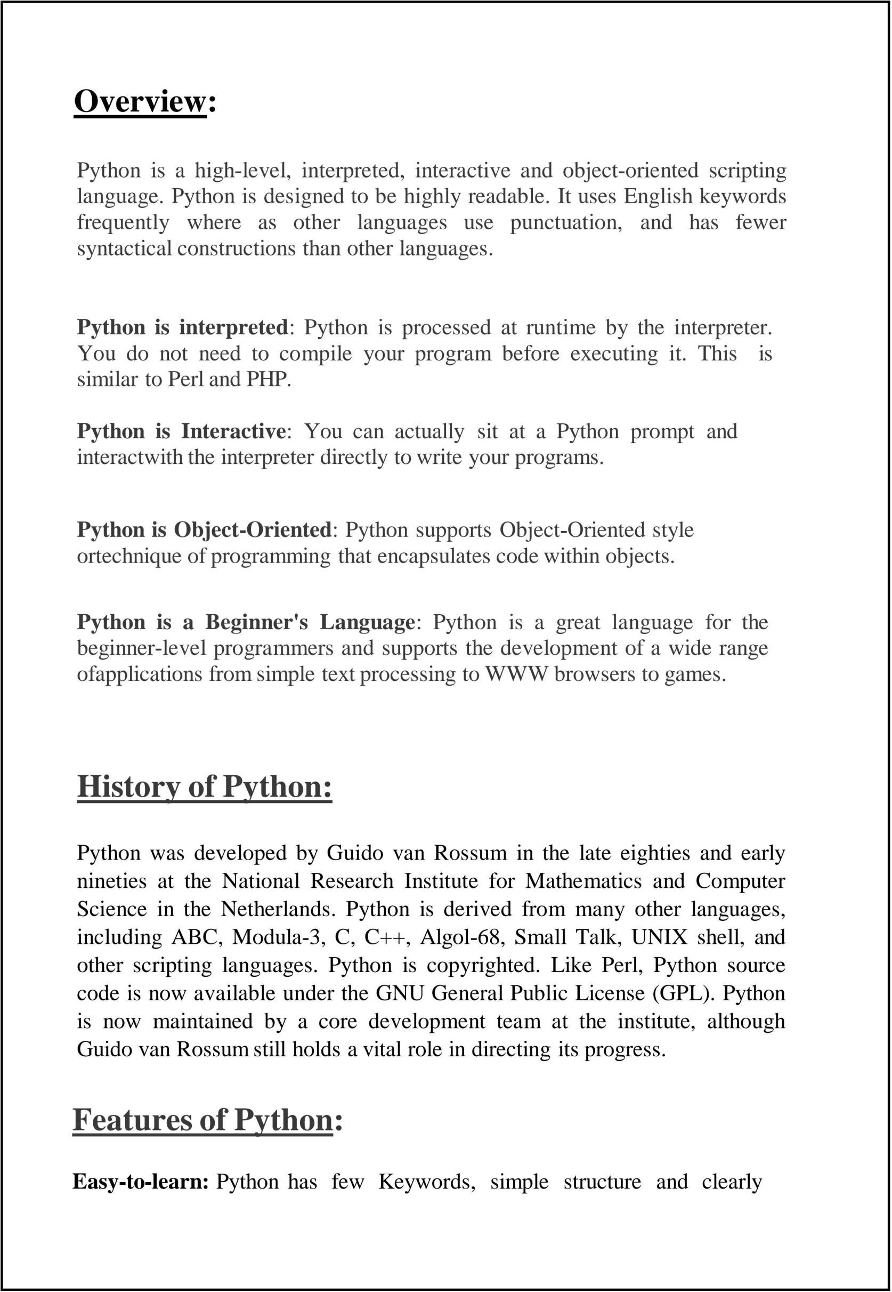

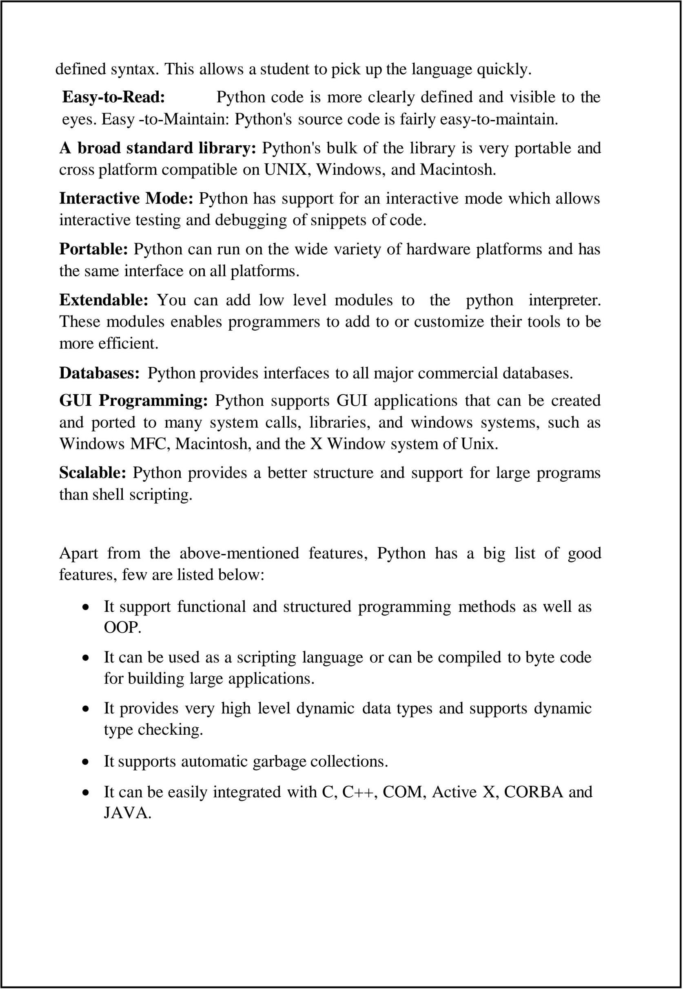

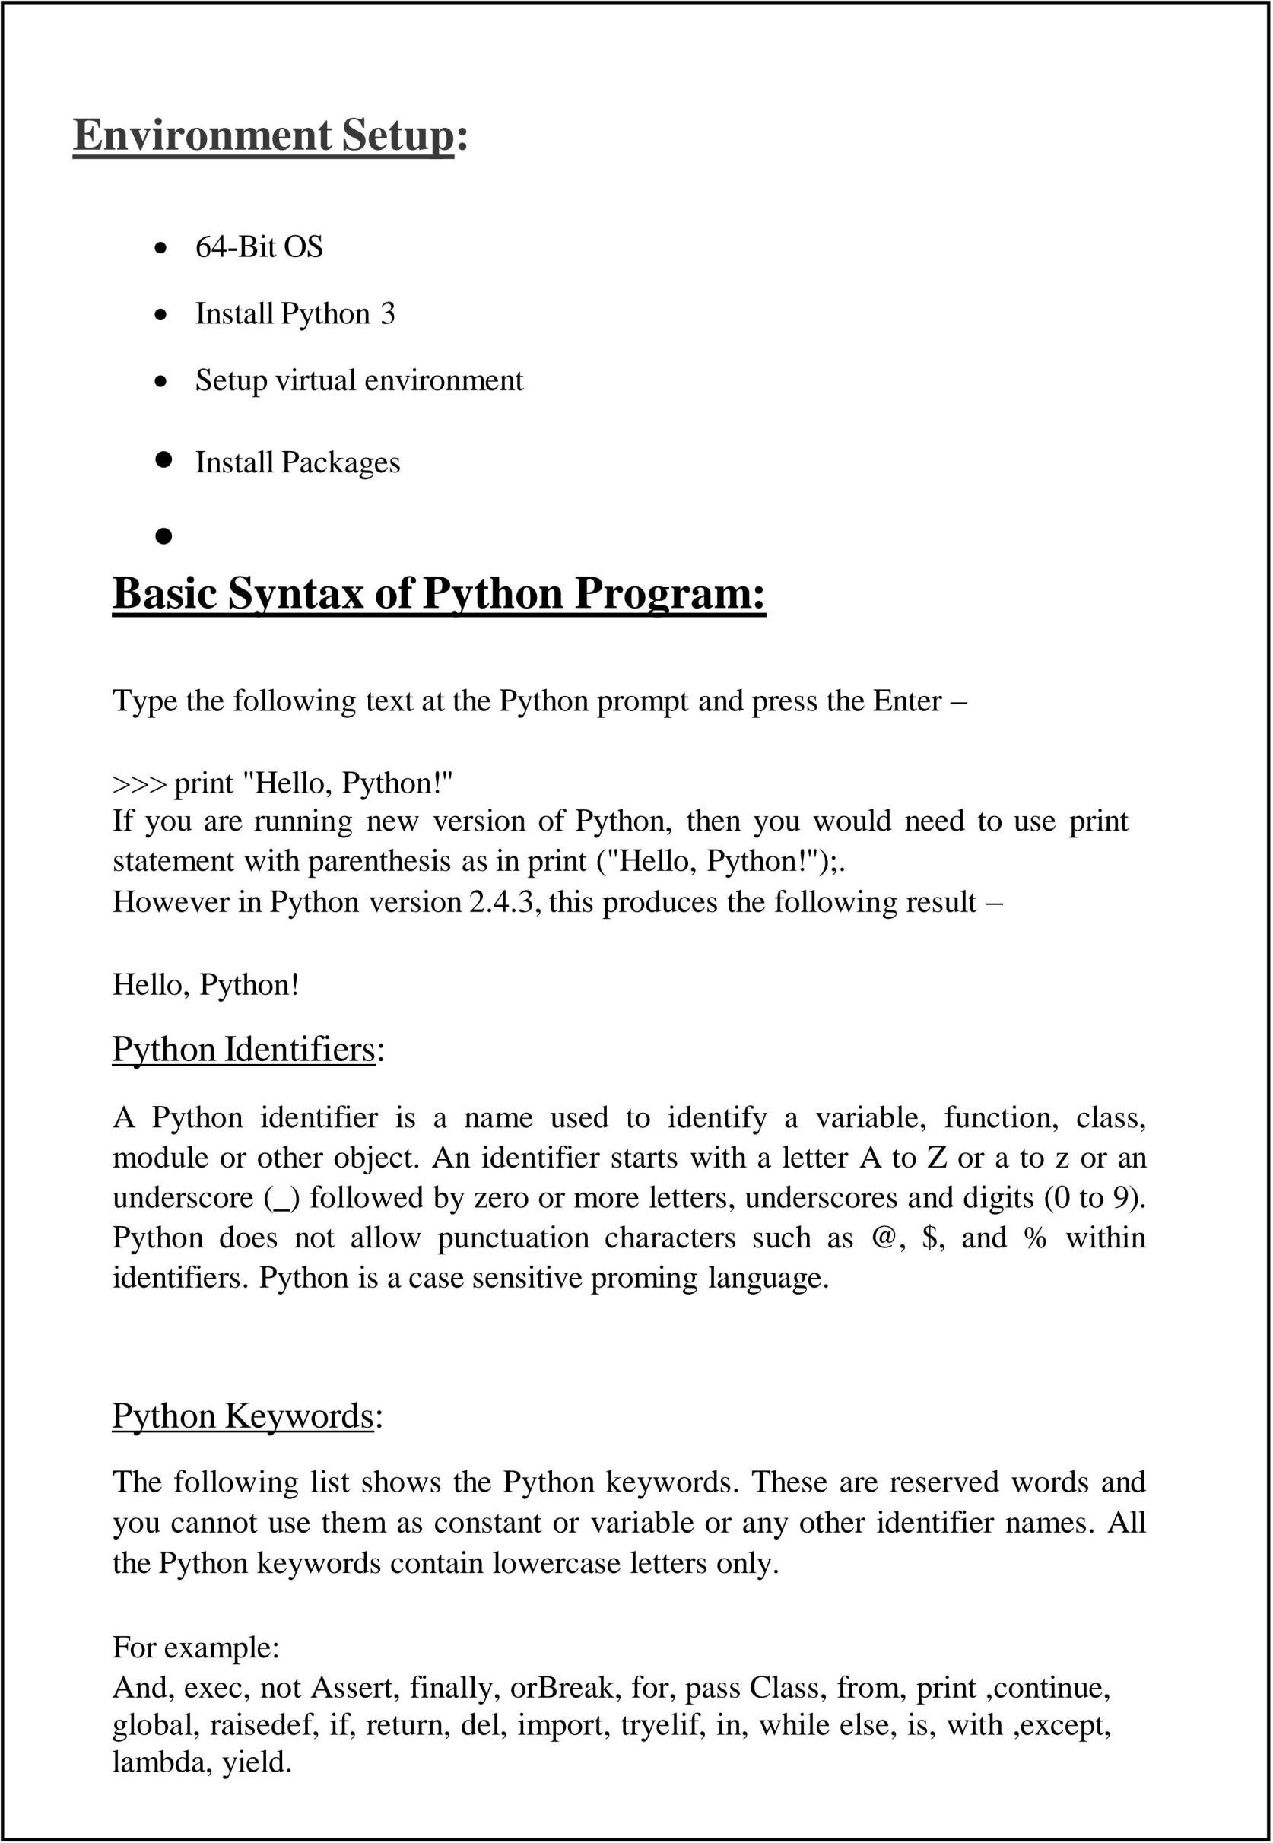

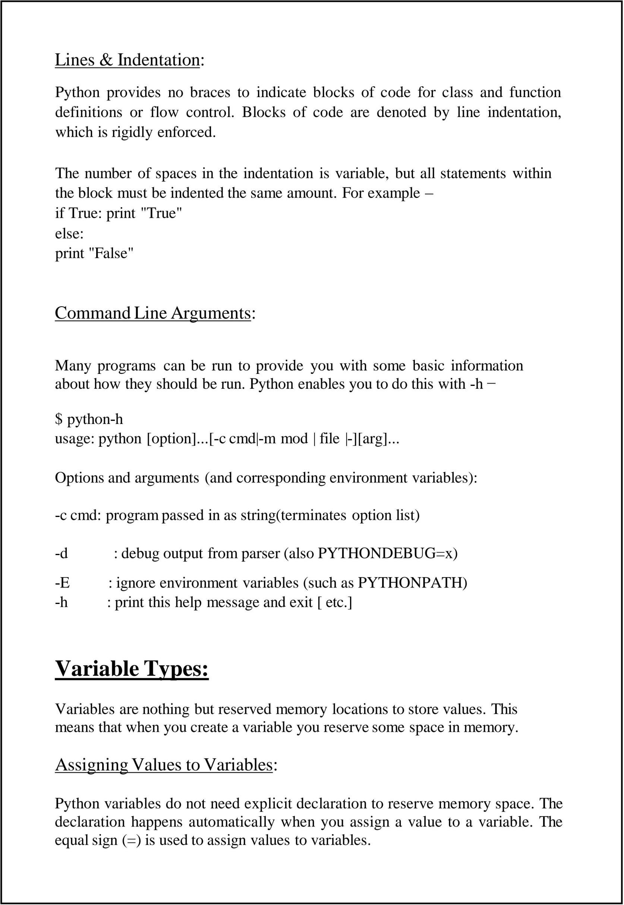

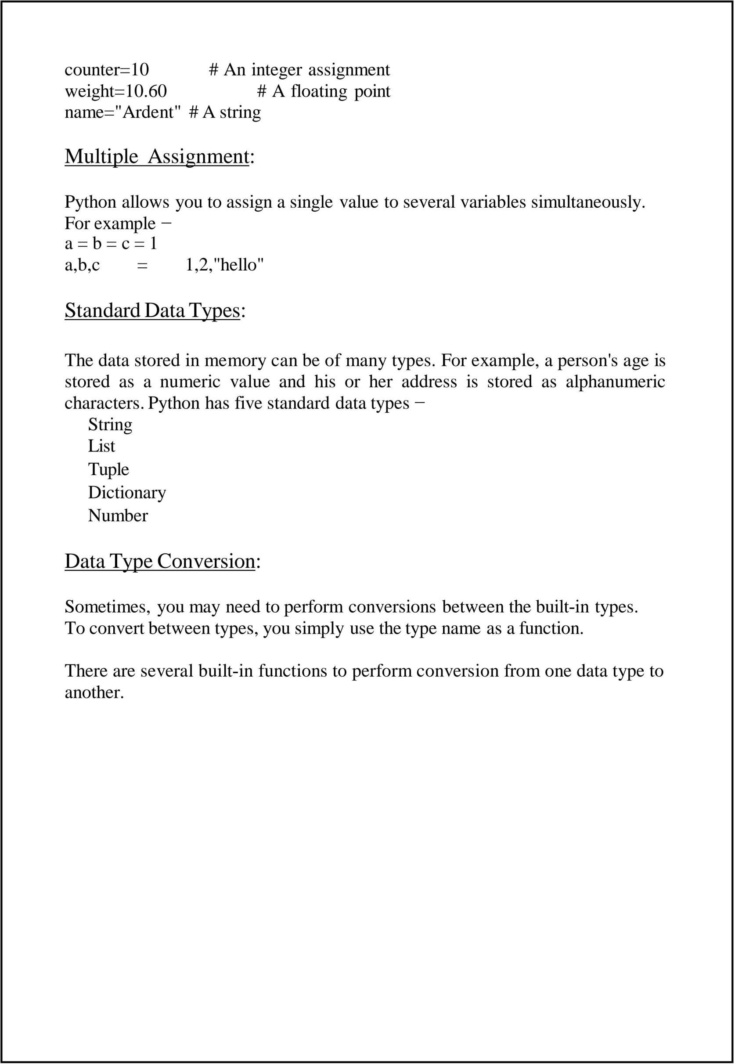

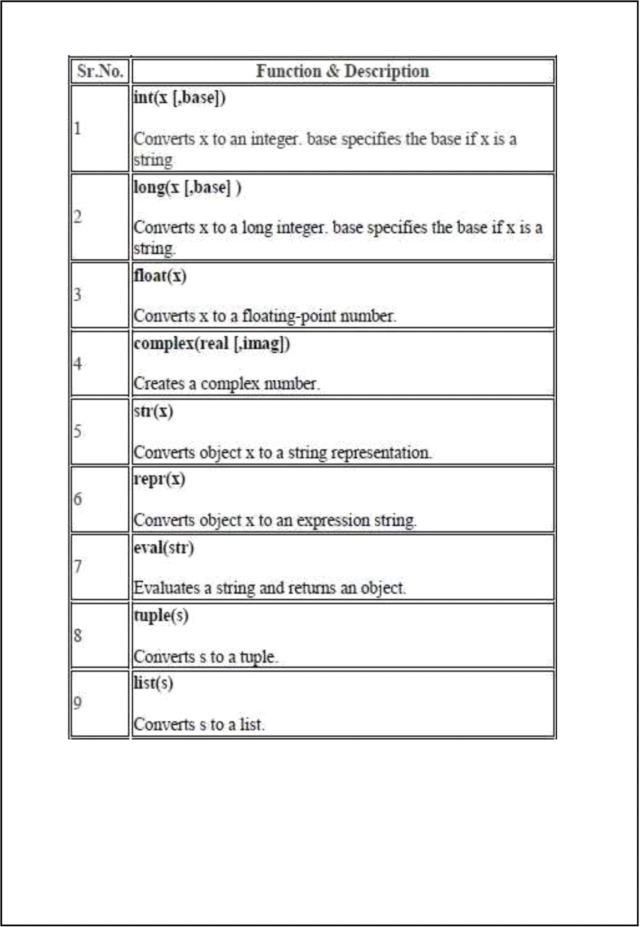

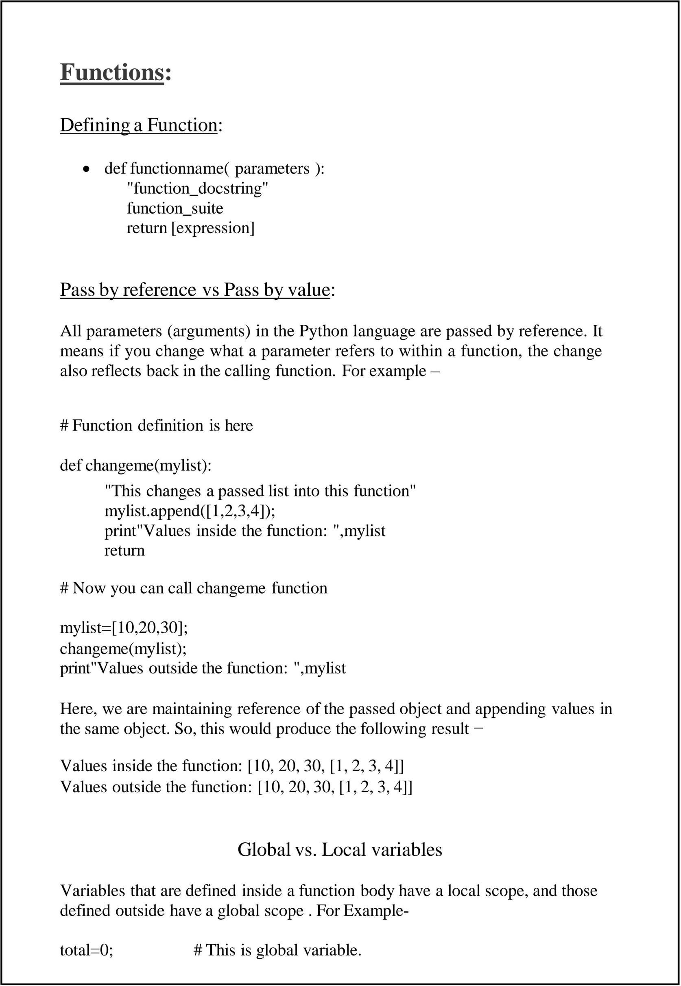

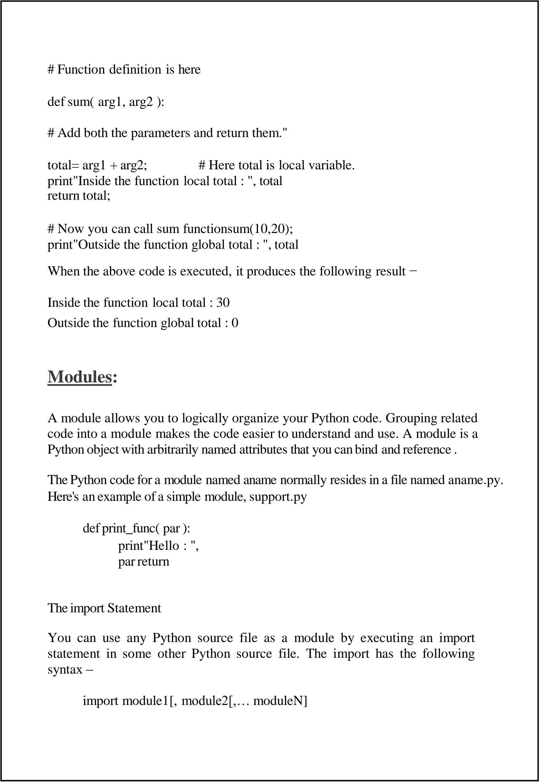

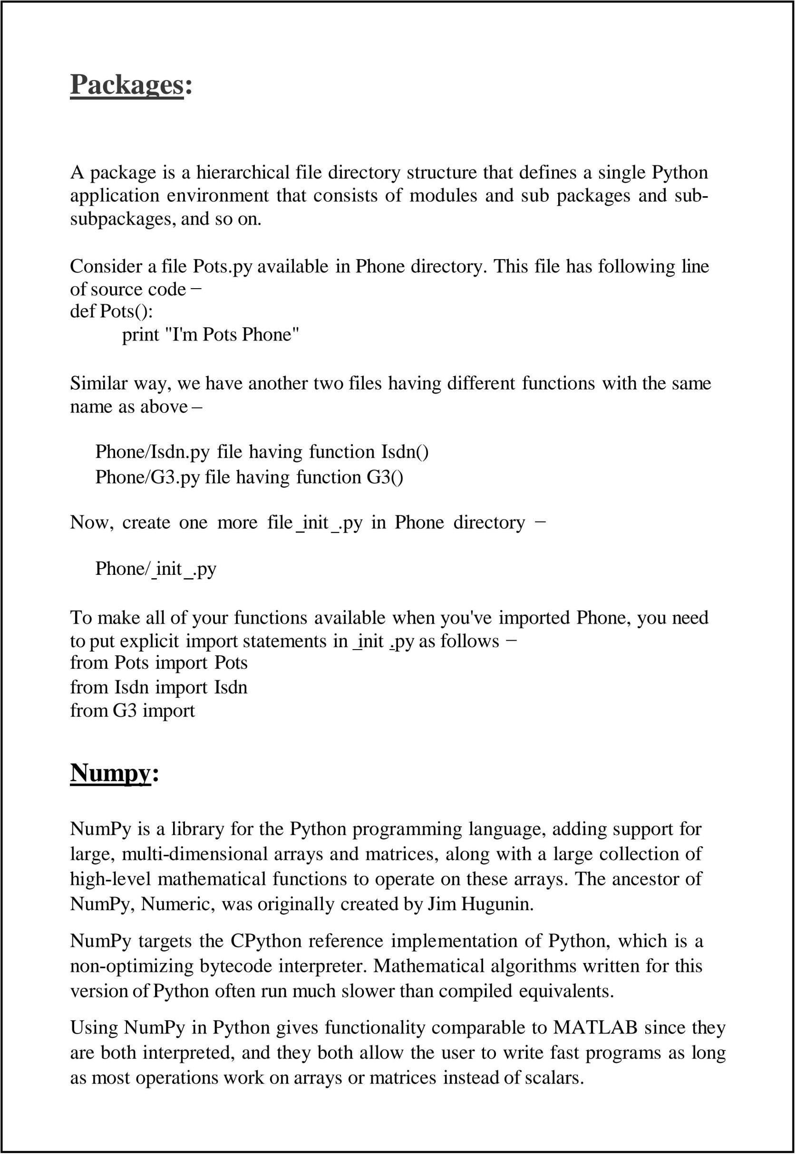

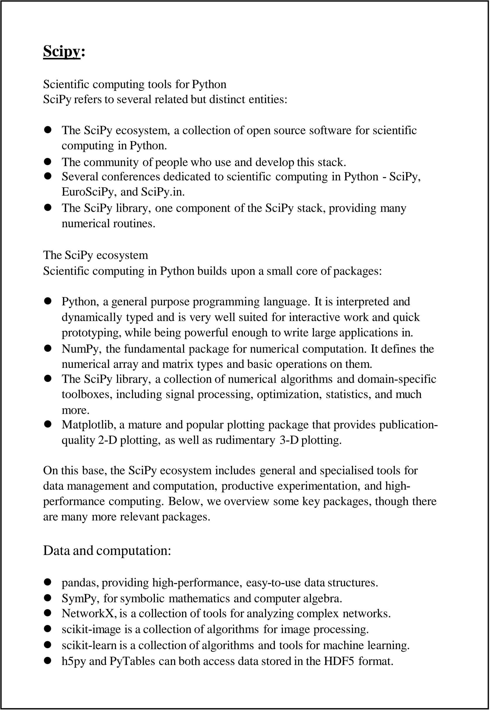

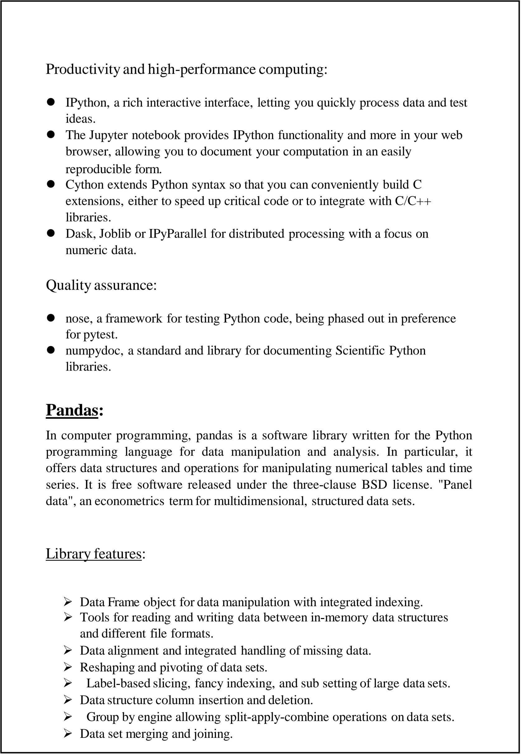

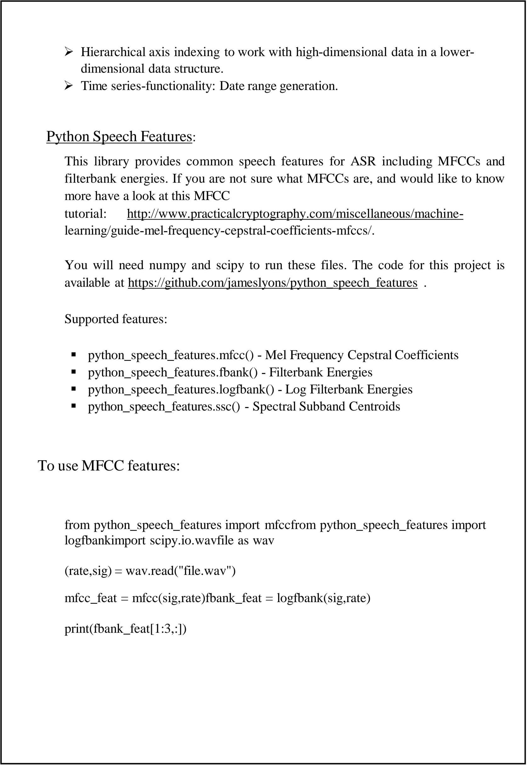

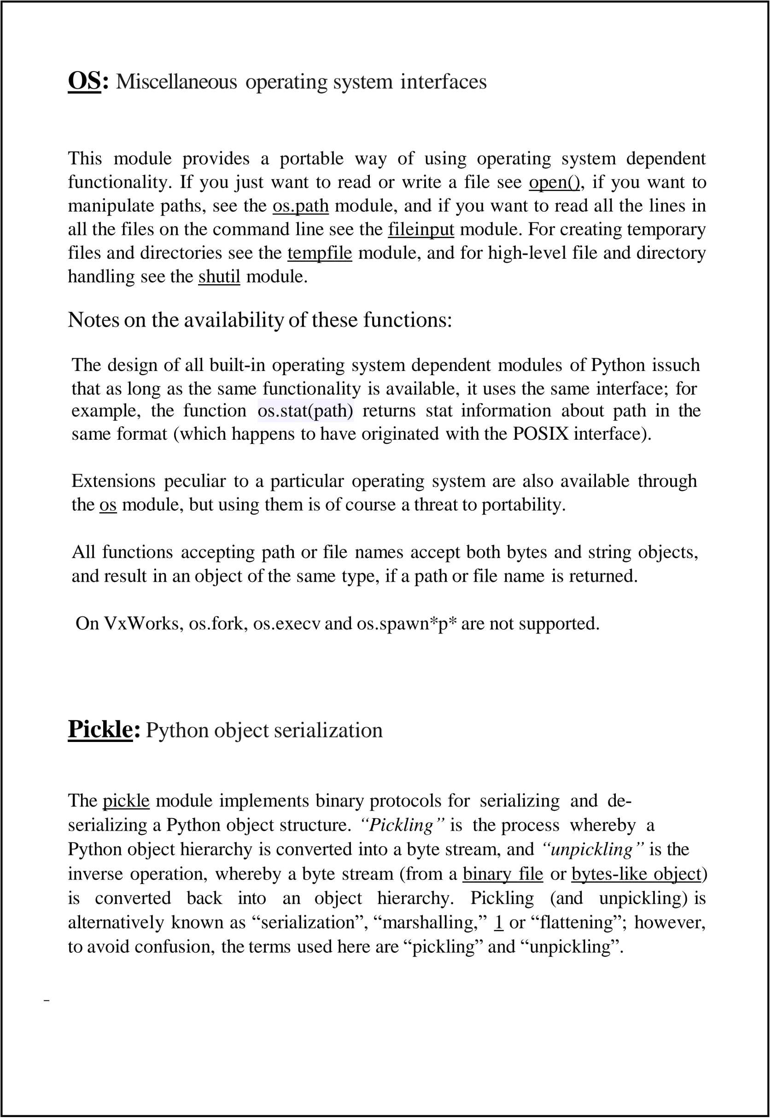

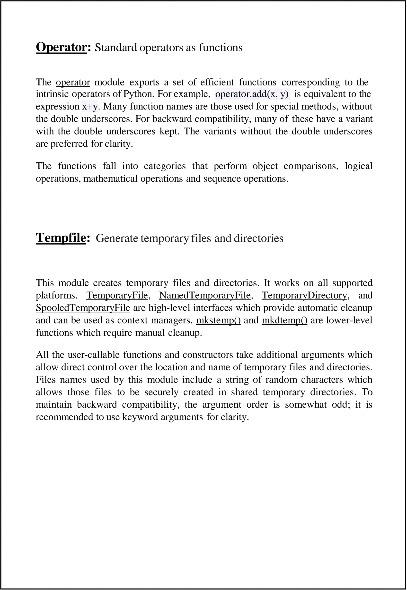

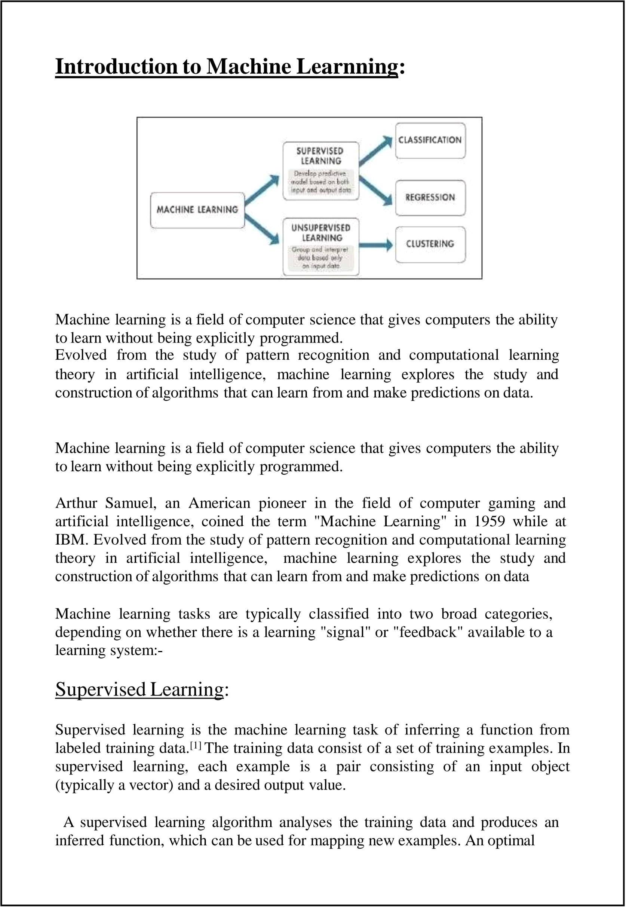

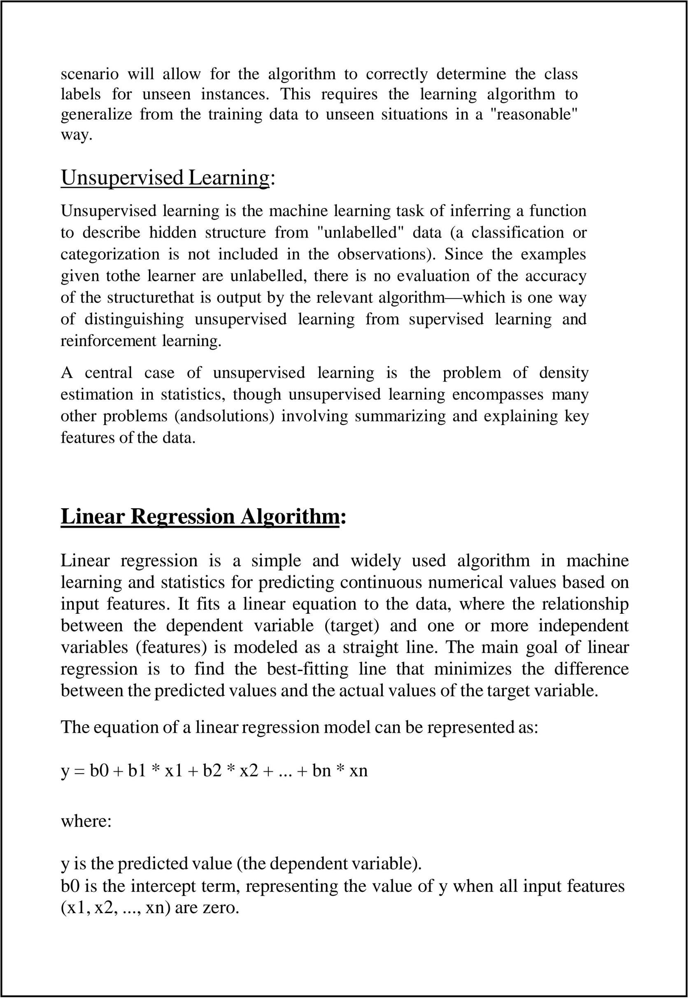

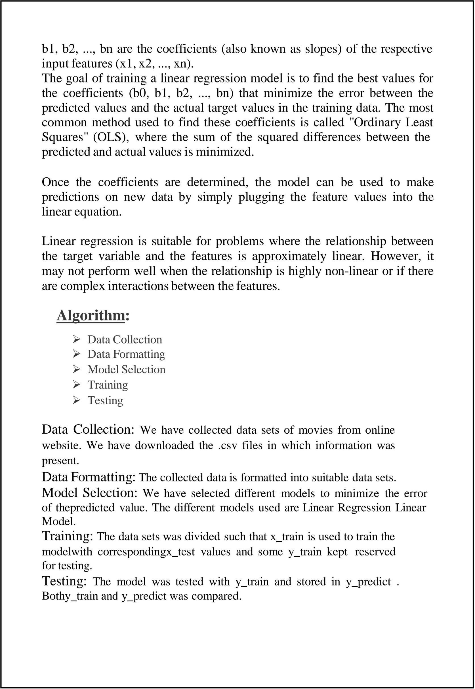  
  
  
  
  
  
  
  
  
  
  
  
***CUSTOMER SEGMENTATION***

***Introduction:-***

Customer segmentation is the process of dividing a customer base into distinct groups based on shared characteristics, behaviors, or needs. This project aims to utilize machine learning and statistical analysis to create a customer segmentation model that uncovers patterns in the data, allowing businesses to target specific customer groups more effectively.

Machine learning techniques, such as clustering algorithms, will be used to identify natural groupings within customer data, based on factors like purchasing behavior, demographics, and preferences. These algorithms help uncover hidden relationships and enable more accurate segmentation.

Statistical analysis will validate and refine the segmentation by providing insights into the key characteristics that define each group. Techniques like correlation analysis will help understand how different variables influence customer behavior.

The ultimate goal is to deliver actionable insights that businesses can use to create personalized marketing strategies, improve customer retention, and optimize resource allocation, leading to enhanced business performance.

**Understanding Dataset**

Analyzing the dataset, which encompasses valuable information on customer demographics, spending behavior, and shopping preferences. step-by-step approach to examining the Mall Customers dataset, focusing on data preparation, pattern exploration, and clustering techniques, all executed using Python and Pandas.

Importing the dataset into the google Colab notebook for analysis:

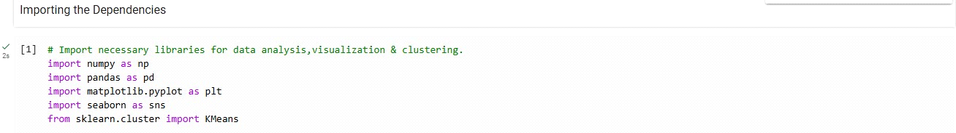

Data collection and Analysis

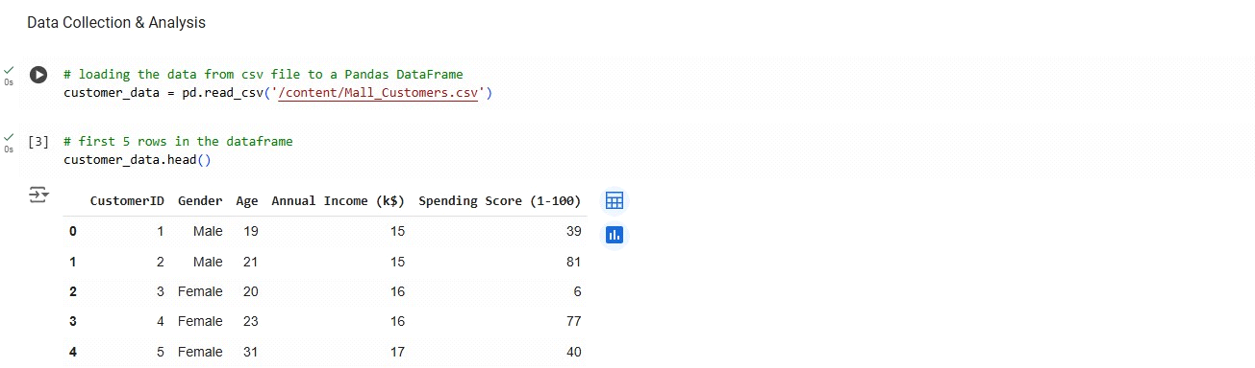

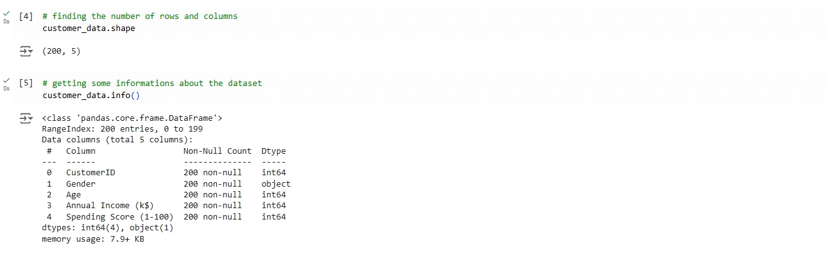

Checking for missing values

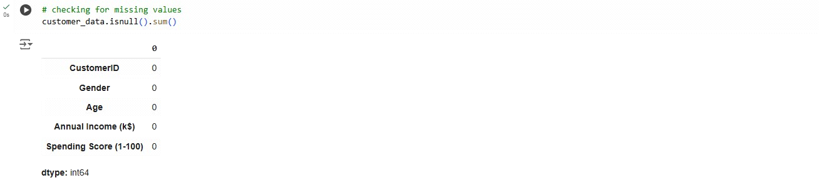

Selection of columns

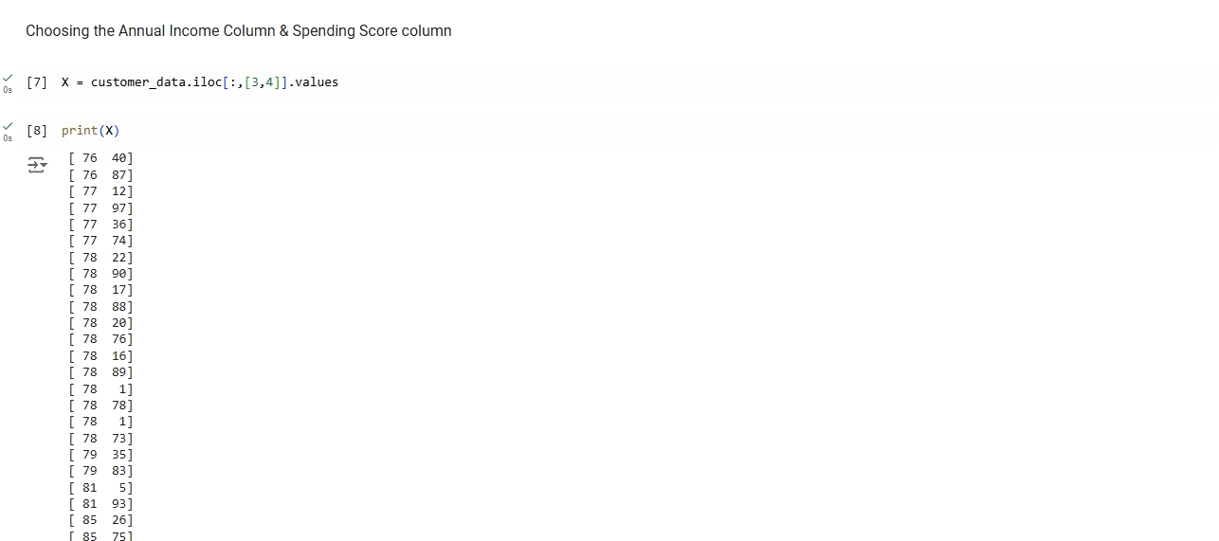

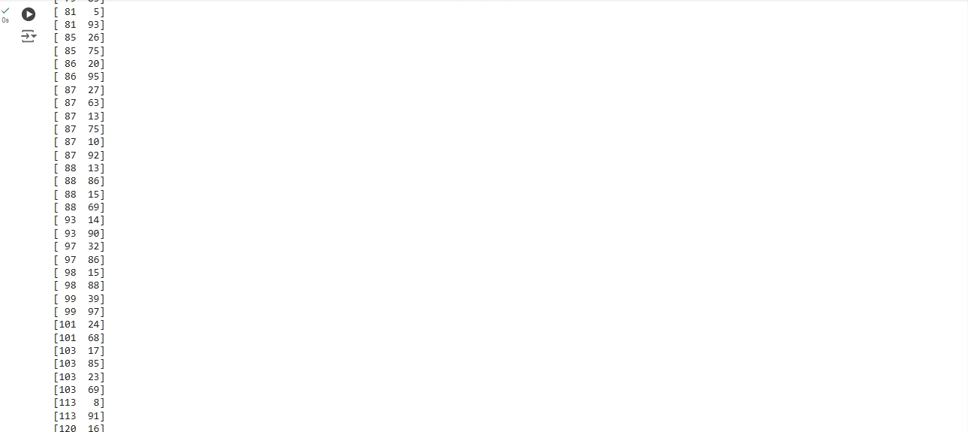

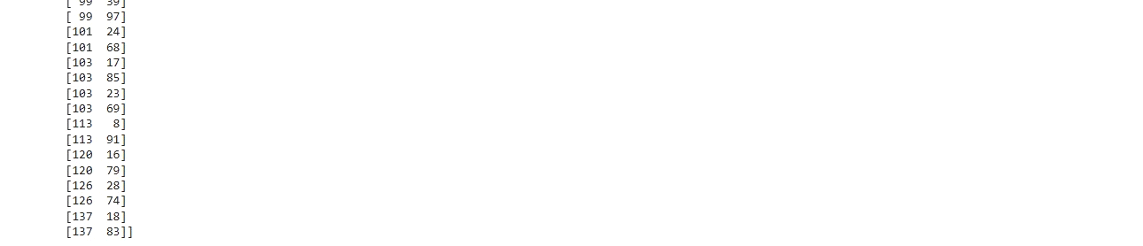

Clustering:

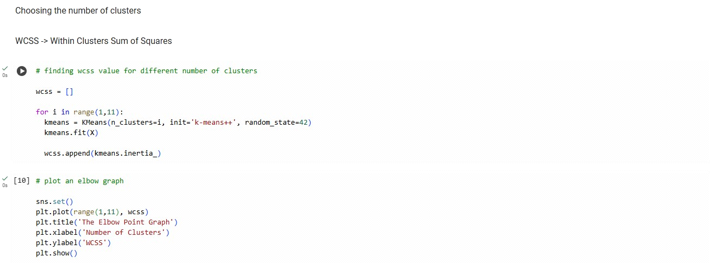

Graph representation

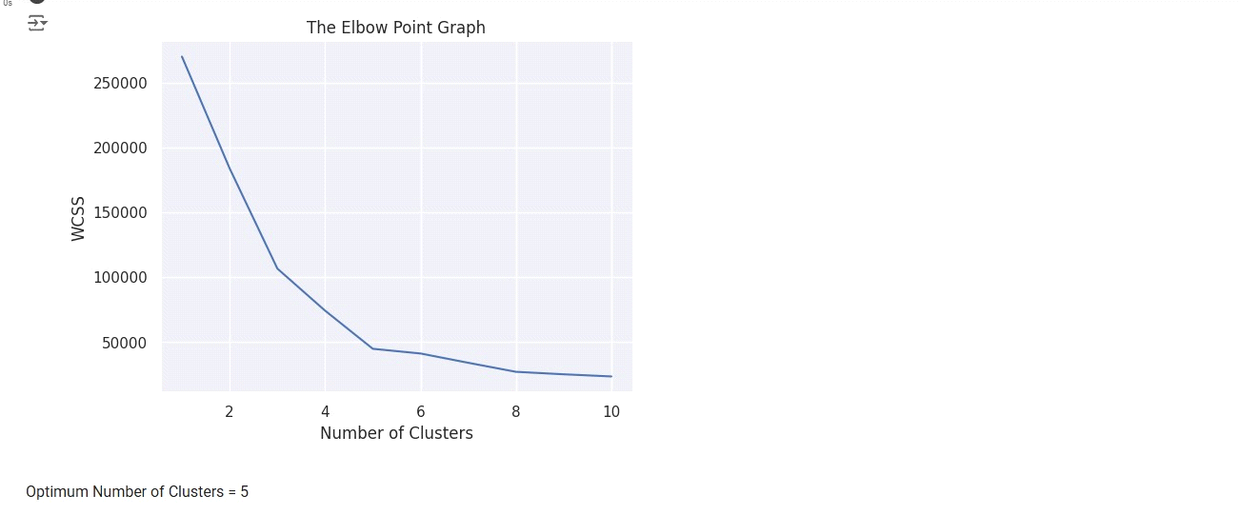

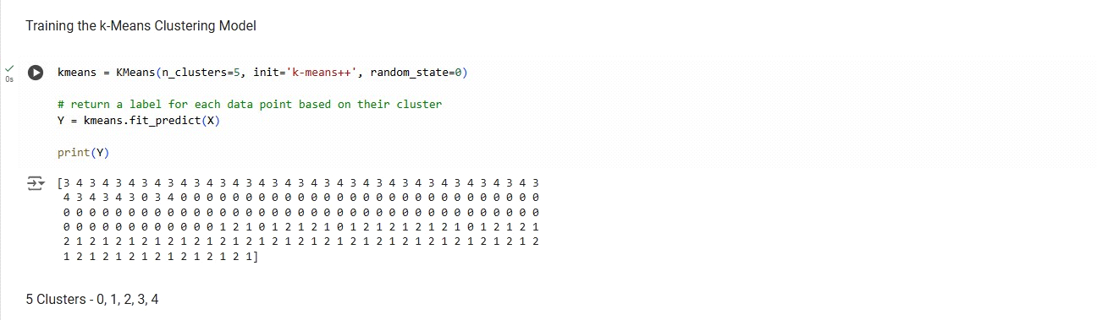

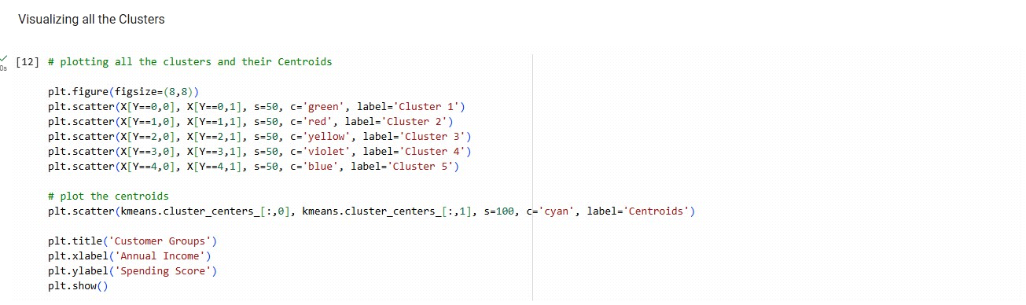

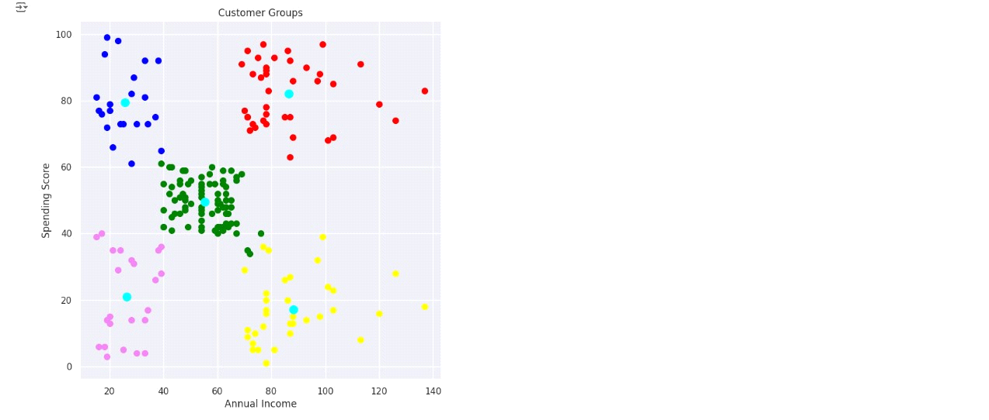

***Conculsion***

*The customer segmentation project utilizing machine learning successfully demonstrated the power of data-driven techniques in identifying distinct customer groups. By applying clustering algorithms such as KMeans, we categorized customers based on features like age, annual income, and spending score. These segments provide valuable insights into customer behavior and preferences, enabling businesses to design targeted marketing strategies, optimize resource allocation, and enhance customer experiences.*

*The use of machine learning in customer segmentation ensures scalable and efficient analysis, making it a vital tool for modern business intelligence. Future improvements could include exploring advanced clustering algorithms, integrating additional data features, and evaluating the real-world impact of these segments on business outcomes.*

***Note:-***

***The datasheet we have used to execute our project on “Customer Segmentation” is given below ---***



***Future Work***1. Model Improvement and Fine-Tuning

Hyperparameter Tuning: Explore techniques like Grid Search or Random Search to fine-tune clustering model parameters (e.g., number of clusters, initialization methods for K-Means).

Alternative Clustering Algorithms: Experiment with other clustering algorithms like DBSCAN, Gaussian Mixture Models (GMM), or Agglomerative Clustering to improve segment quality and handle different types of data distributions.

Deep Learning Approaches: Investigate the use of deep learning-based methods like Autoencoders for anomaly detection or self-organizing maps (SOMs) for complex data structures.

2. Incorporating Temporal and Real-Time Data

Dynamic Segmentation: Explore the possibility of adapting segments over time as customer behavior changes. For example, incorporate time series analysis or real-time data streaming to update customer segments.

Customer Churn Prediction: Combine segmentation with churn prediction models to proactively identify customers at risk of leaving and create retention strategies for different segments.

3. Integration with Business Processes

Customer Insights Dashboard: Build an interactive dashboard using tools like Power BI or Tableau to visualize the customer segments and the insights derived from them, helping business teams make data-driven decisions.

Integration with Marketing Systems: Implement the segmentation model into real-time marketing or recommendation systems. This could include personalized product recommendations, email campaigns, or promotional offers tailored to each customer segment.

Customer Lifetime Value (CLV): Integrate CLV prediction with the segmentation model to further refine business strategies around high-value segments and optimize resource allocation.

4. Data Enrichment

Additional Data Sources: Integrate external datasets to enrich customer profiles, such as demographic, geographic, or social media data. Enriching the data could lead to more accurate and meaningful segmentation.

Text Analysis and NLP: Incorporate unstructured data, such as customer reviews or support tickets, using Natural Language Processing (NLP) techniques to uncover hidden patterns and segment customers based on sentiment or feedback.

5. Evaluation and Validation

Better Evaluation Metrics: Explore more sophisticated evaluation metrics for clustering, such as Silhouette Score, Davies-Bouldin Index, or Adjusted Rand Index, to validate the quality of the segmentation.

Cluster Stability: Assess the stability of the segments over time and their ability to generalize to new data (e.g., using cross-validation or bootstrapping techniques).

6. Scalability and Real-Time Application

Scalable Implementation: Implement the model in a scalable way to handle large datasets efficiently, using cloud platforms like AWS, Google Cloud, or Azure for real-time processing and predictions.

Real-time Segmentation: Design and deploy an end-to-end system that segments customers in real-time based on new interactions, allowing businesses to dynamically adjust marketing strategies.

7. Ethical and Bias Considerations

Bias Mitigation: Investigate potential biases in the segmentation model, such as skewed demographic representation or over-representation of specific groups, and implement methods to mitigate these biases.

Privacy Concerns: Address privacy and data security concerns, ensuring compliance with data protection regulations (e.g., GDPR) when handling sensitive customer information.

8. Cross-Industry Applications

Industry-Specific Customization: Explore applying the customer segmentation model in other industries, such as finance, healthcare, or e-commerce, and tailor the segmentation methodology to each industry's unique characteristics and customer behavior patterns.

***“ References”***

* [*https://m.youtube.com/*](https://m.youtube.com/)
* [*https://www.kaggle.com/*](https://www.kaggle.com/)
* [*https://github.com/*](https://github.com/)
* [*https://openai.com/index/chatgpt/*](https://openai.com/index/chatgpt/)

*THANK YOU*